Response to Melanie’s feedback to our pitch and answering further questions that panel wanted to ask. We are now awaiting a response.   
  
I have sent this email to her on the 4th January but I have forwarded the email again on the 15th as we did not get a response and just an automated message to say she will be back at work the following week. This is proof 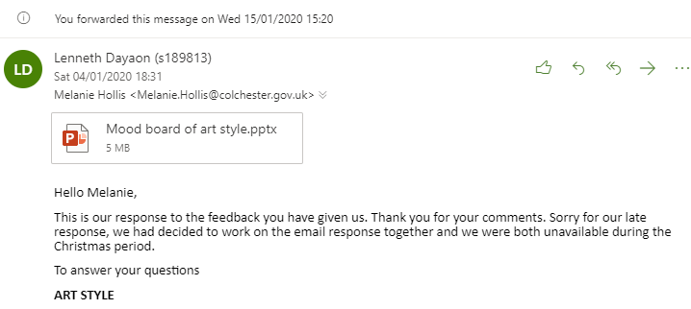

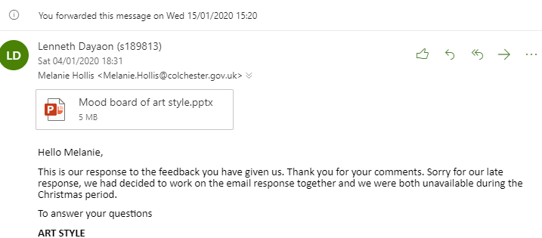

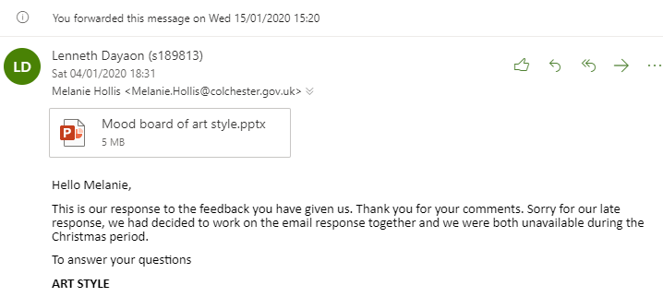

**Response to your feedback**

Lenneth Dayaon (s189813) <L.Dayaon@UOS.AC.UK>

Sat 04/01/2020 18:31

To:

* Melanie Hollis <Melanie.Hollis@colchester.gov.uk>

1 attachments (5 MB)

Mood board of art style.pptx;

Hello Melanie,

This is our response to the feedback you have given us. Thank you for your comments. Sorry for our late response, we had decided to work on the email response together and we were both unavailable during the Christmas period.

To answer your questions

**ART STYLE**

The art style we are going for is papercraft/storybook mixed with cel-shaded. I have attached our mood board of the games that are a similar art style to what we are going for. I will attach my concept art in a different email as I am just refining them to what we would like.

In the mood board attached, I have annotated the images to give a better understanding of the visuals we are going for.

The reason why we are using these types of art styles is that they allow us to use the photographs we have taken of the mansion interior and modify them to better suit our style, without having to create more asset from scratch. This is useful because it is easier, for example, for someone to connect a portrait and a cel-shaded version of that portrait rather than an asset made in a significantly different style.

The papercraft art style helps to make it for a wider variety of audiences and it helps with our timeframe.

**RETURNING EXPERIENCE**

How this game might be adapted so that families who visit again can use the game without feeling that they were just repeating their first experience.

Thank you for this question! From discussing this, we have decided that in terms of returning experience. It would be very difficult to make something completely new without jeopardizing the purpose of the museum game. We can make minor alterations that add variety to the game but it won’t have a significant change to the player experience. For example, an update on different clothing in one of the mini-games.

 We could add a time trial or block off rooms to make it more challenging in a returning experience, however, this would be detrimental to the people experiencing the game for the first time. This could also make the museum experience more rushed and more focused on the game, rather than what is at the mansion.

Another option to this question is updating each mini-game post-release. So each room would have an entirely new game, in a span of say every 2 months. Another option is a surprise unlockable bonuses that can be unlocked for more replayability but that may distract from the main purpose of being a game that aids the mansion.

I would also like to add that it is very difficult to make educational games, such as ours, to have replay value, because it’s difficult to teach something that has already been learned, without boring the player. It is also difficult to make new content for a mansion museum as the game content needs to relate to the mansion.

This can be discussed further if you have any further questions or suggestions with this.

**For your additional questions**

**Which museums/galleries/family venues you researched to support this idea; were there any which particularly inspired you or helped you to rule out other solutions?**

To find a solution to this brief I had looked at a variety of museums, varying from the United States and some regions in the UK. Only a few had stood out to me and most lacked a solution at all.  
The few that stood out to me was a Ted talk by Sarah Kenderdine (link below) who talked about the ways museums are creating a powerful interactive experience using modern technology. <https://www.youtube.com/watch?v=VXhtwFCA_Kc>

This ted talk was far from something I could make but it inspired me to dig deeper on how to make the museum experience different and more engaging.

Another museum I researched, which I cannot provide a link to as I have not been able to find the link. The museum had made a game for the Ship exhibit. People had to make a ship with the correct bearings and sizes and materials to make sure the ship didn’t sink. They had to use the information of the exhibit to help them make a ship that didn’t sink or one that had lasted through a duration of time. This had asked the player to look through the details of information to be able to make an accurate ship. This inspired me, but I felt like it was too much for this brief.

The inspiration that the museum gave me was to gamify the museum experience. It eventually led me to a game called Gen. A game from the National Museums Scotland and Aardman. This game is a virtual pet that you have to look after and sustain by using the biomedical objects from the museum. This is the link for it: <https://www.youtube.com/watch?v=aILi-pZslk4>  
  
This is what had led me to start creating this concept for the brief where there would be a character that acts as an interlocker who can connect the mansion content with an interactive experience. Allowing people to have a greater engagement with the museum and to let them learn the contents of the mansion in a more immersive way.

Throughout my research, I had ruled out so much, but these are what stood out the most. If you would like more information, feel free to ask as I would be happy to tell you about the process and answer further questions.

**How you would evaluate during the test phase?**  
Test phase evaluation can be conducted in multiple ways such as simple observation of how players act while playing the game. However, one core element we could use to observe the game’s success is by tracking how well players do. If players generally do well it shows that they are using the information they learn in the museum to progress in the game. Whereas poor game success rates would imply the players may be too focused on the game and are not using the museum to learn, or we don’t utilize what the museum teaches well enough.

**Whether you would plan for any user input; if not, why not?**  
For user input, we plan to gain evaluative feedback during the testing phase by providing players with a paper form/question sheet to fill out allowing them to give user input and express their opinions on aspects of the game for further iteration.

**TIMEFRAME**  
For our timeframe, after the presentation. We discussed that it may have been too long after what was said in our last meeting. We have decided to cut down to 8 Weeks and we are scaling our workload down to 5 mini-games for separate chosen rooms. Which we will soon justify why we have chosen those specific rooms. If you have any suggestions on which rooms you would like more attention to or want people to get more out of, please don’t hesitate to say.

I hope this has been helpful. Thank you for your time and we hope to hear back from you soon.

Many Thanks,

Lenneth Dayaon & Willoughby Axtell